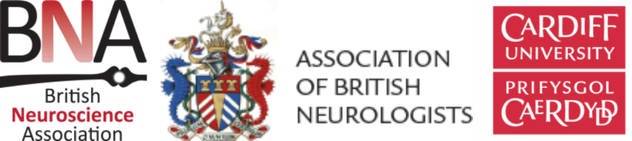
EARLY CAREER BURSARIES APPLICATION FORM
‘Meeting of Minds’ symposium – 29th September 2016, Cardiff
(for Undergraduates, Postgraduates and Early Career Scientists)
Completed forms should be returned to the BNA office: office@bna.org.uk
The deadline for receipt of bursary applications is: August 15th 2016
Name:
Department:
Institution:
Address:
Postcode:
Email:
Course of study:
Name of supervisor:
Year PhD was awarded (early career scientists):
Membership type (please tick) | BNA Undergraduate/Student ABN Student  BNA Postgraduate (Masters or PhD) ABN Junior/Overseas  BNA Early Career Scientist ABN Associate/Affiliate
Title of submitted abstract:
Estimated cost of travel/accommodation*:

* Successful applicants will be expected to provide scans of all receipts corresponding to travel and accommodation towards the meeting

Please explain in the box below – in no more than 200 words – how you expect to benefit from attending the meeting:

