If you cannot enter text, click on ‘View’ (above) and ‘Edit document’

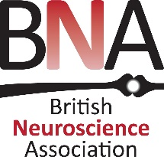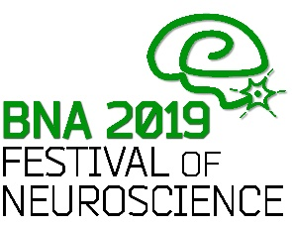

BNA Early Career Bursaries Round II - application form
BNA2019 Festival of Neuroscience, 14-17 April 2019 - CCD, Dublin, Ireland

Eligibility criteria:
- the applicant must be currently registered as an undergraduate or as a postgraduate: or have been awarded their PhD (date of successful viva voce) or completed their F2 no earlier than 1 January 2014
- the applicant must be registered for the BNA2019 meeting and have had their abstract accepted for poster presentation
- the applicant will be presenting a poster as FIRST AUTHOR
- the expectation is that applicants will have sought additional funds from elsewhere
Please note that we can only pay grants in pounds sterling: any fees incurred for converting to different currencies will be subtracted from the amount awarded.

Please complete ALL sections of the form.

Completed forms should be returned to the BNA office: office@bna.org.uk

The deadline for receipt of bursary applications is midnight on Thursday 28th February 2019.

Applicant Information
Full Name: | Enter title | Enter first name | Enter last name
 | Title | First name | Last name

Institution : | Enter institution.
 | University / Hospital / Institution

 | Enter city | Enter city
 | City | Country

Phone: | Enter phone number. | Email | : Enter email address.

Career stage: | Click to select from dropdown list.
If you selected ‘other’ please state here | Enter career stage if different from those in the dropdown list above.
Graduation date: | For students: please give date you expect to graduate / complete your studies  mm/yyyy | For ECRs: please give graduation date of your highest degree or completion of F2:  mm/yyyy

Information about your attendance at BNA2019
Please give title of your poster abstract: | Click or tap here to enter poster title.
Please explain in the box below – in no more than 200 words – how you expect to benefit from attending the meeting:
MAX 200 words

Funding

Total estimated travel / accommodation costs*.  (Note that we are collecting this information for planning purposes only; this may not be the amount awarded.) | State expected costs in pounds sterling.
Any additional costs*. | Additional costs in pounds sterling.
How much are you applying for? (up to £250) | Amount requested in pounds sterling.
Are you seeking funding elsewhere? If yes, please state source.: | Enter text.

Disclaimer and Signature
I certify that my answers are true and complete to the best of my knowledge.
Signature (please click on icon and upload image): |  | Date: | dd/mm/yy.

* Successful applicants may be asked to provide scans of receipts corresponding to childcare expenses incurred when attending the meeting
**details of applicants will be retained by the BNA for purposes of administering the grants for this and future BNA Festivals for a period of 8 years, after which they will be deleted. See more information about our data protection notice at https://www.bna.org.uk/disclaimer/

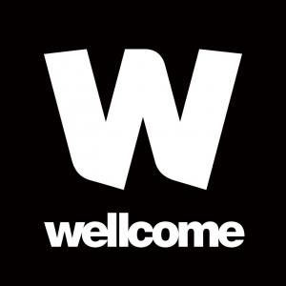
We are very grateful to Wellcome for supporting these bursaries.

