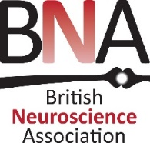
LGR funding application form
This application form should be completed and returned to:
The BNA office, office@bna.org.uk

Please complete and return this form
Name of applicant(s):
Local group(s) represented:
Lead email address:
Funding call: | 31st May ☐ 31st October ☐
Total amount of funding requested (£): |  | Outline budget included*: | YES ☐
Activity/event summary:
Full description of activity/event (maximum 750 words)

(please submit a separate document if more space is required):
Benefits to BNA members:
Incentives to recruit new BNA members:
Payment details if funding is awarded: please give details for a bank transfer or cheque payment.
Bank transfer (preferred payment method) | Account number:
 | Sort code:
 | Reference for payment:
OR  Cheque payment | Cheque payable to:
 | Name and address to whom cheque should be sent:
* Applications without an outline budget cannot be considered

